10. ReactJS-HOL

Create a React Application named “officespacerentalapp” which uses React JSX to create

elements, attributes and renders DOM to display the page. Create an element to display the heading of the page.

Attribute to display the image of the office space

Create an object of office to display the details like Name, Rent and Address. Create a list of Object and loop through the office space item to display more data.

To apply Css, Display the color of the Rent in Red if it’s below 60000 and in Green if it’s above

60000.

code:

PS C:\Users\lenovo> node –v V22.17.0

PS C:\Users\lenovo> npm -v 10.9.2

PS C:\Users\lenovo> npx create-react-app officespacerentalapp PS C:\Users\lenovo\ officespacerentalapp > npm start

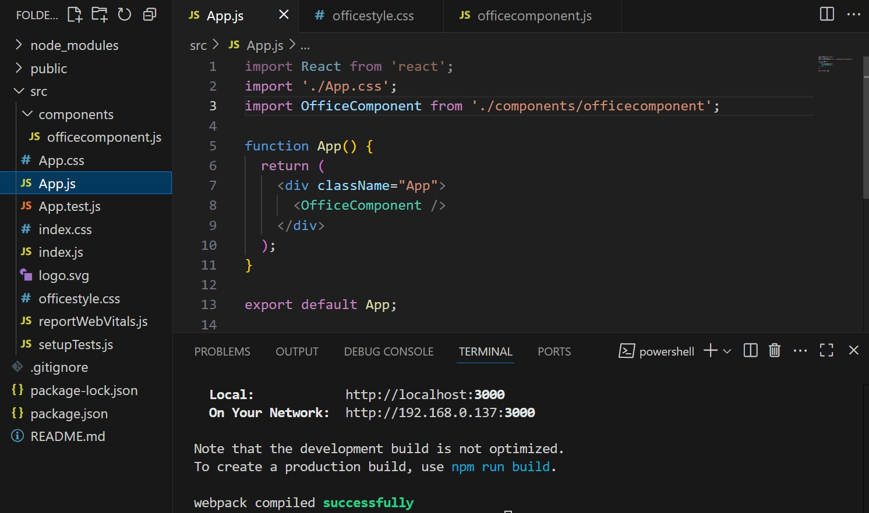

officecomponent.js

import React from 'react'; import '../officestyle.css';

const officecomponent = () => { const office = {

name: 'DBS', rent: 50000,

address: 'Chennai',

image: '<https://spacen.in/images/home/s_2.jpg>'

};

const rentClass = office.rent < 60000 ? 'low-rent' : 'high-rent'; return (

<div className="office-container">

<h1>Office Space , at Affordable Range</h1>

<img src={office.image} alt="Office" className="office-image" />

<p><strong>Name:</strong> {office.name}</p>

<p className={rentClass}><strong>Rent: Rs. {office.rent}</strong></p>

<p><strong>Address:</strong> {office.address}</p>

</div>

);

};

export default officecomponent;

OUTPUT:

When rent<60000

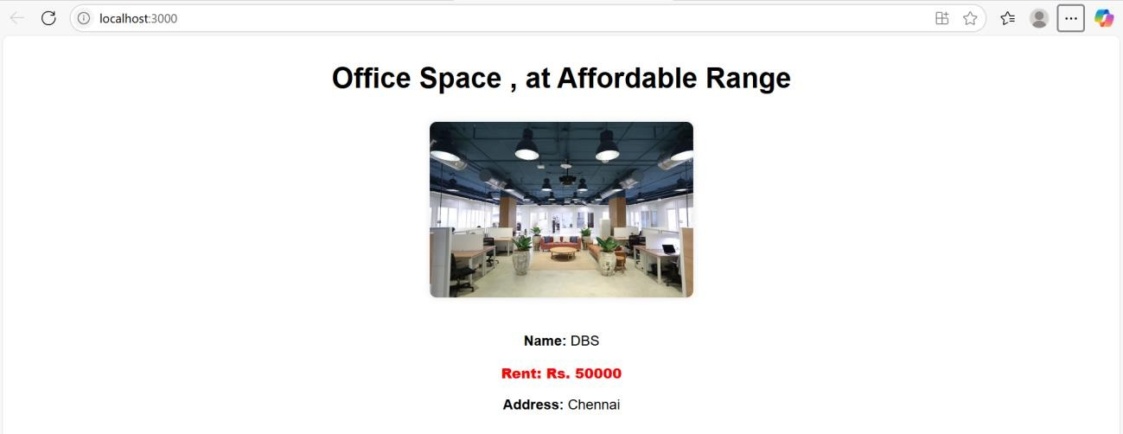

When rent>60000

